Got lunch?

Order, pay in advance, and get boxed lunches for your team delivered directly to Moscone Recreation Center during SWC’s 11th annual “They Are Worthy” benefit softball tournament, Saturday, July 12!

Choose from either:

BBQ Chicken – “’World Famous and highly addictive,’ these delicious marinated Chicken Fillets are grilled to tasty perfection on our Wolf Grill. DANGER…extremely addictive.” $9.00

BBQ Short Ribs – “Meaty Beef Ribs, served sizzling off our maniacally hot grill; a traditional favorite.” $12.00

All lunches include rice, sprout salad, and lettuce salad.
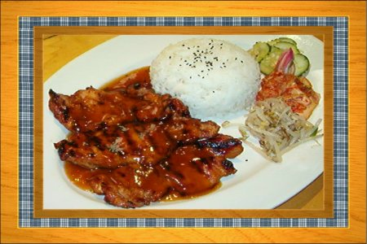
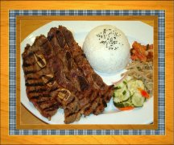
Prepared by:

Hahn’s Hibachi 6618 Steiner
San Francisco CA

ALL ORDERS WITH PAYMENT MUST BE RECEIVED BY SWC BY 2:00PM, FRIDAY, JULY 11

NAME: TEAM:

Phone: email:

# of BBQ CHICKEN LUNCHES: x $ 9.00 = $

# of BBQ SHORT RIB LUNCHES: x $12.00 = $

TOTAL $

(Please make checks/money orders payable to Sports for the World’s Children,
or send via PayPal to swc@swcfoundation.org.)

THANK YOU FOR SUPPORTING SPORTS FOR THE WORLD’S CHILDREN!!!


2346 – 32nd Avenue, San Francisco CA 94116
tel/fax: (415) 566-3487, email: swc@swcfoundation.org

